**IUBAT- International University of Business Agriculture and Technology**

**Assignment on Assembly Language**

**(CSC 197)**

**Prepared for:**

Humayun Kabir Biswas

Assistant Professor

**Prepared by:**

Name: Imtiaz Zaman Mehedi

ID: 17103024

Section: C

BCSE Department

Date: July 22, 2018

**Answer to the question no: 1**

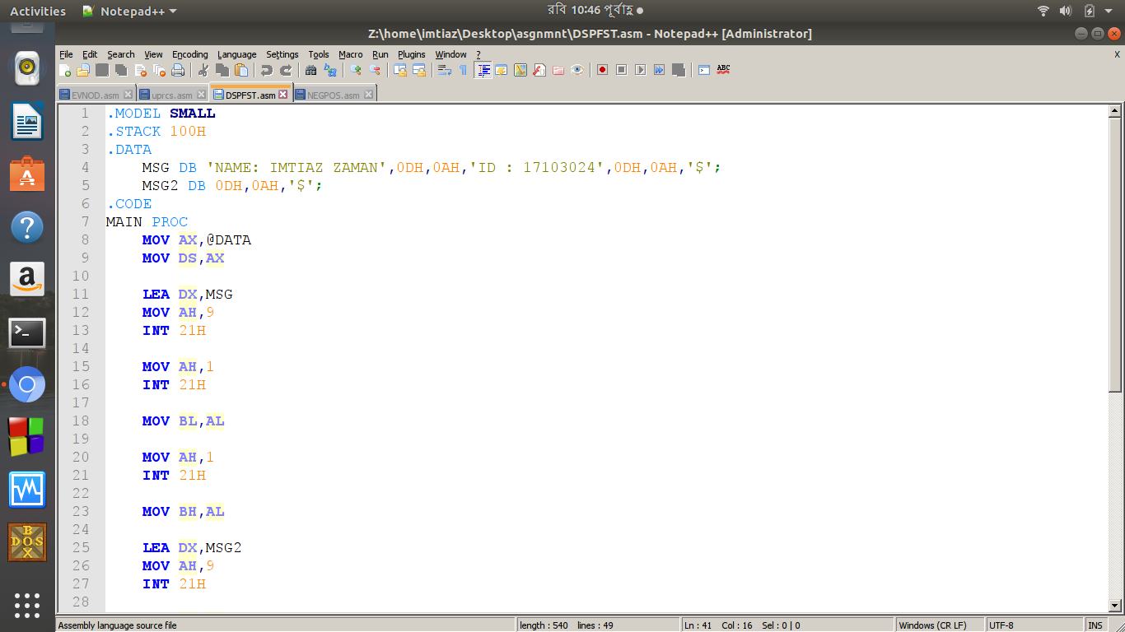

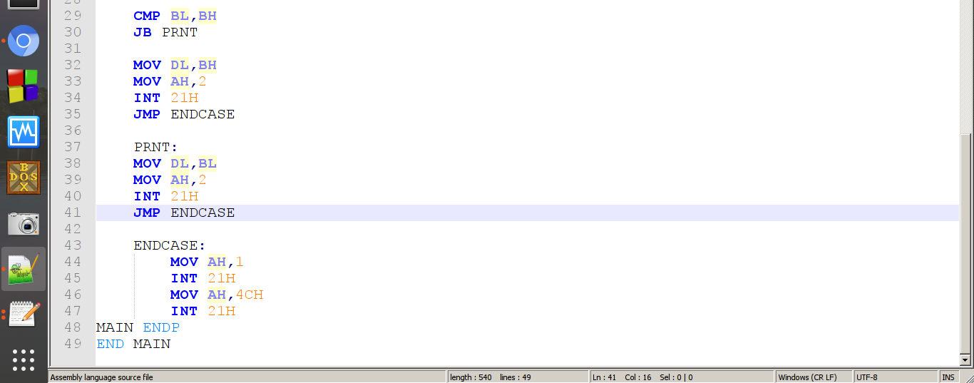

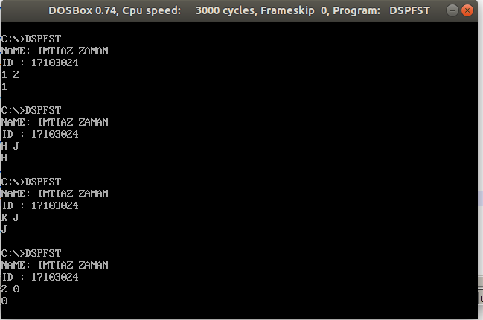

**Answer to the question no: 2**

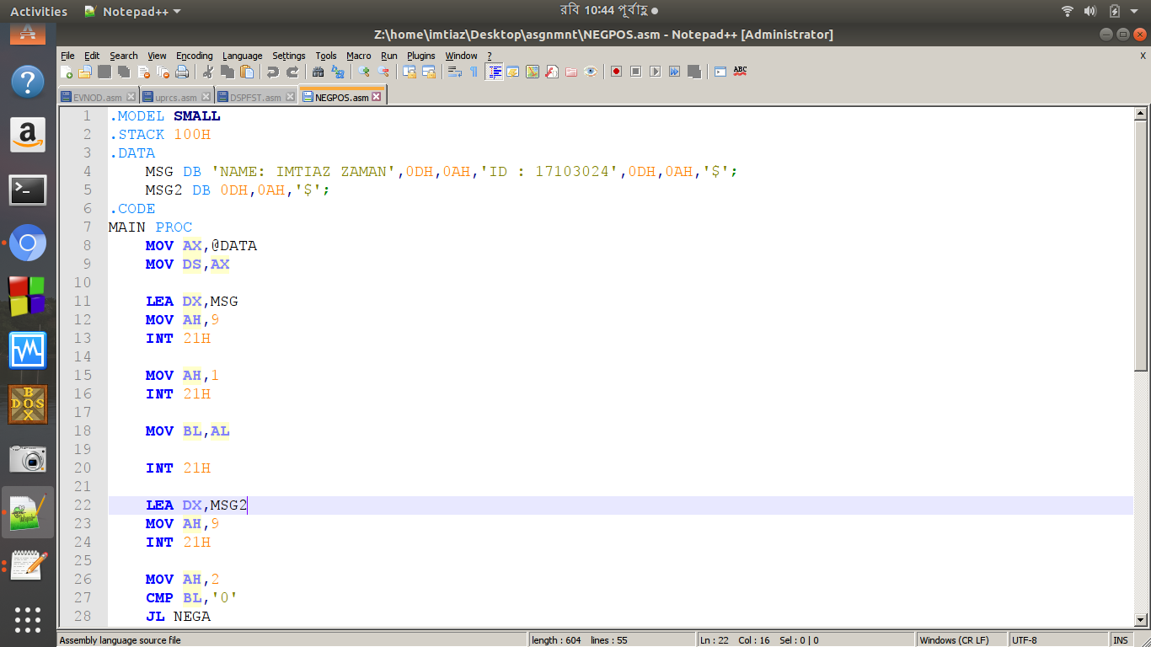

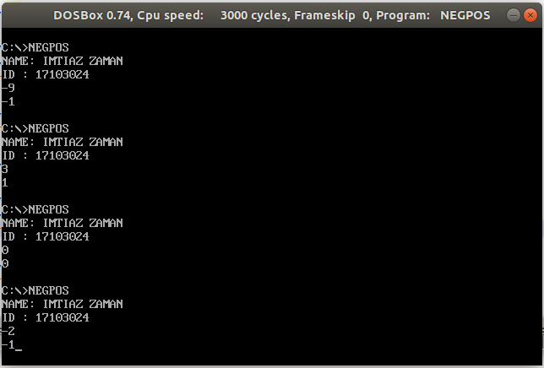

**Answer to the question no: 3**

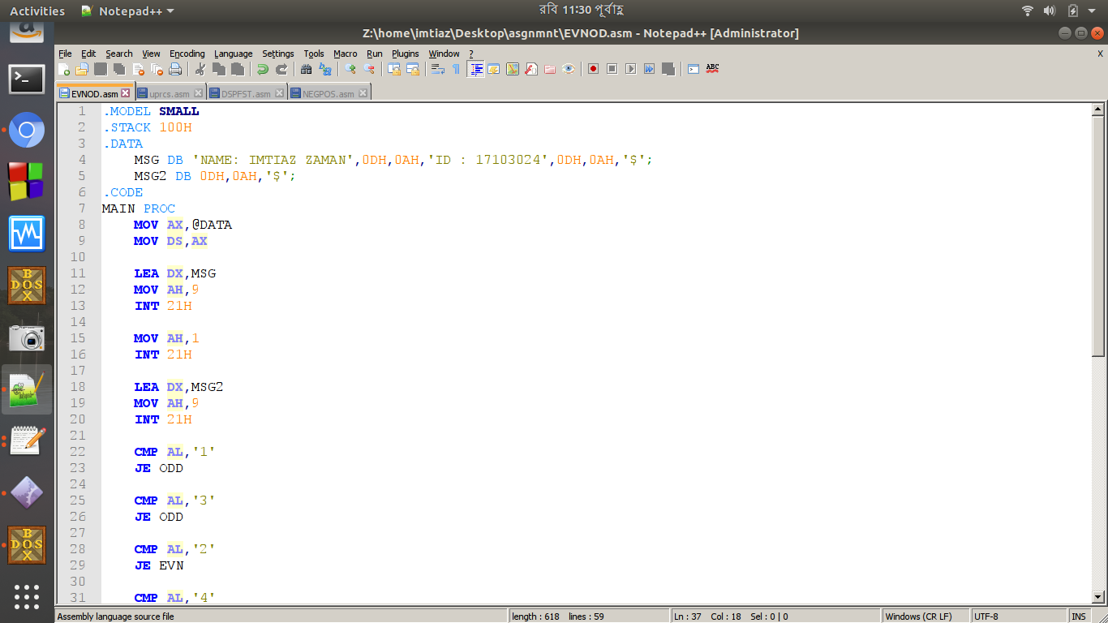

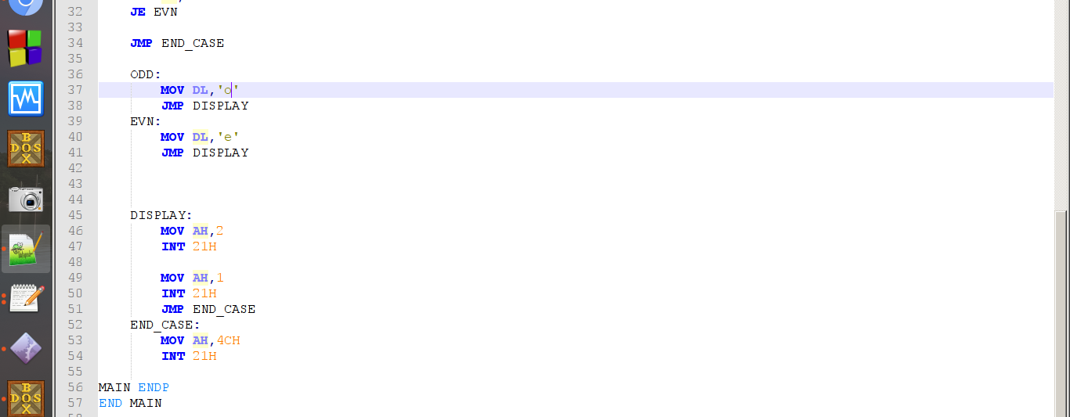

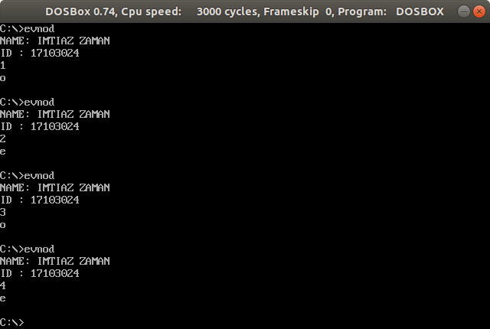

**Answer to the question no: 4**

